# Lab 3

## Yu Feng ID: z5094935

# Exercise 1

## Q1.

Content type: text/html

Size: 6966 bytes

Last Modified: Wed, 03 Aug 2016 07:17:13 GMT

Accept-Ranges indicate whether the server is allowed to accept range request or not.

## Q2.

Content-type: text/HTML

Size: 6966 bytes

## Q3.

GET /people.html HTTP/1.1

Host: [www.vision.ucla.edu](http://www.vision.ucla.edu)

## Q4.

The same IP address may have multiple websites. The server can identify which web page should send according to addition host name.

# Exercise 2

## Q1.

It set a cookie. Because set-cookie has data.

Ucla do not set cookies.

## Q2.

**2** cookies. **Google.com** installed it.

## Q3.

**Vision.ucla.edu** installed **4** cookies.

Maybe the browser set these cookies(?).

# Exercise 3

## Q1.

Both server and client running HTTP version1.1.

## Q2.

Accept-language: en-us

## Q3.

IP address of the client: 192.168.1.102

Host: IP address 128.119.245.12 host name: gaia.cs.umass.edu

## Q4.

HTTP/1.1 200 OK

## Q5.

Client: Mozilla/5.0

Server: Apache/2.0.40 Red Hat Linux

## Q6.

Last-modified: Tue, 23 Sep 2003 05:29:00 GMT

Date: Tue, 23 Sep 2003 05:29:50 GMT

‘Date’ is the time when the messages were originated.

‘Last-modified’ is the time when the server believes the variant was last modified.

## Q7.

It’s persistent connection. ‘Connection’ is keep-Alive.

## Q8.

73 bytes

## Q9.

<html>\n

Congratulations. You’ve downloaded the file lab2-1.html!\n

</html>\n

# Exercise 4

## Q1.

No

## Q2.

Yes, the server return a line-based text data said “You’ve downloaded the file lab2-2.html”.

## Q3.

Yes, the HTTP header indicated it.

## Q4.

Yes, it contains the date value – Tue, 23 Sep 2003 05:35:00 GMT.

## Q5.

Status code: 304 Not Modified

Server did not return the file. Because the Last-Modified date did not comply with the inclusion of the IF-MODIFIED-SINCE filed.

# Exercise 6

## Q1.

UDP

## Q2.

Query: Source Port: 3742 Destination Port: 53

Response: Source Port:53 Destination Port:3742

## Q3.

Destination: 128.238.29.22. It same as default DNS server.

## Q4.

1 question. Type A. It does not have answer.

## Q5.

## 

It don’t have authority RRs.

## Q6.

128.238.29.22 It’s the same as the default local DNS server.

## Q7.

Type:NS Class: IN

It does not contain any answer.

## Q8.

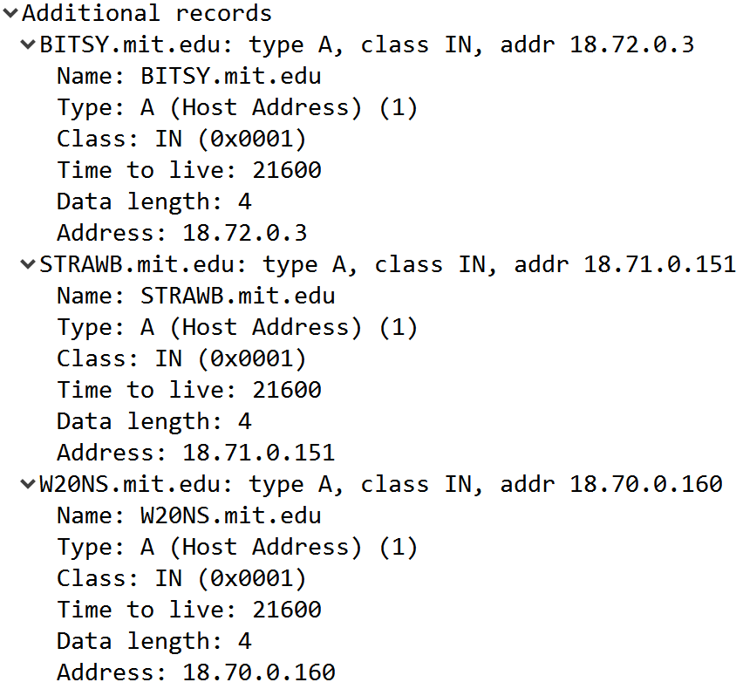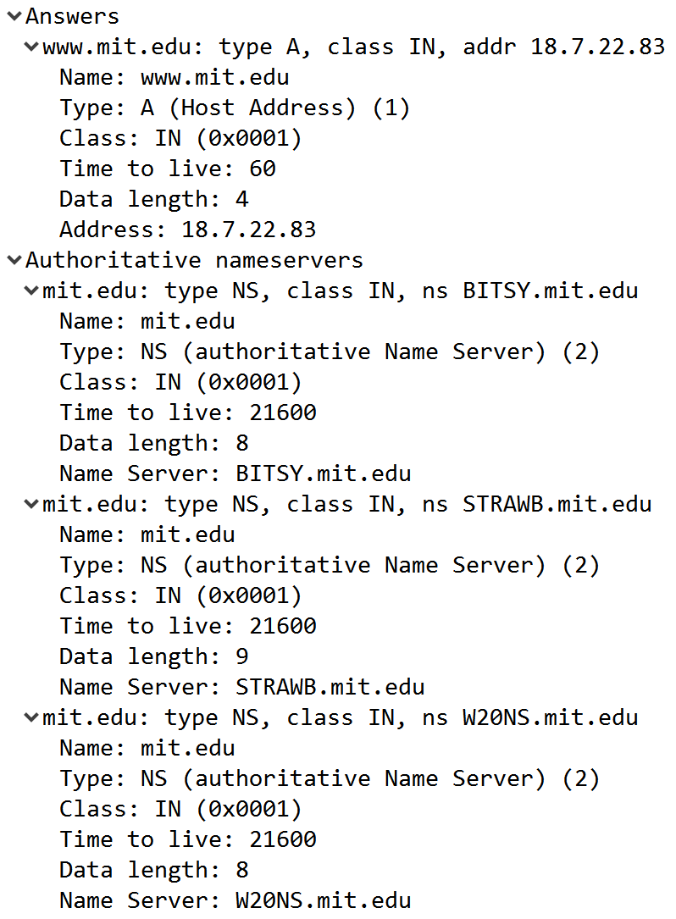

MIT have three authoritative name servers which resolve domain names.

## Q9.

It’s different.

MIT use content delivery network. The proxy servers AKAMAIEDGE send the content of the webpage.

# Exercise 7

## Q1.

Query type is A.

## Q2.

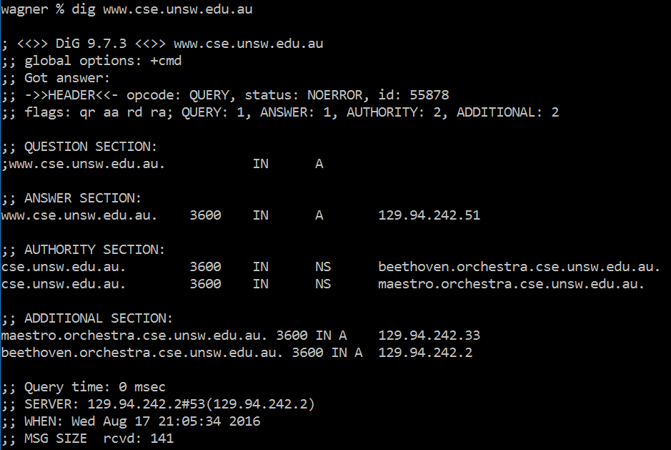

No canonical name. IP: 129.94.242.2 IP: 129.94.242.33

host aliasing are easier to remember. Canonical name for the server link to different IP address which distribute the load.

## Q4.

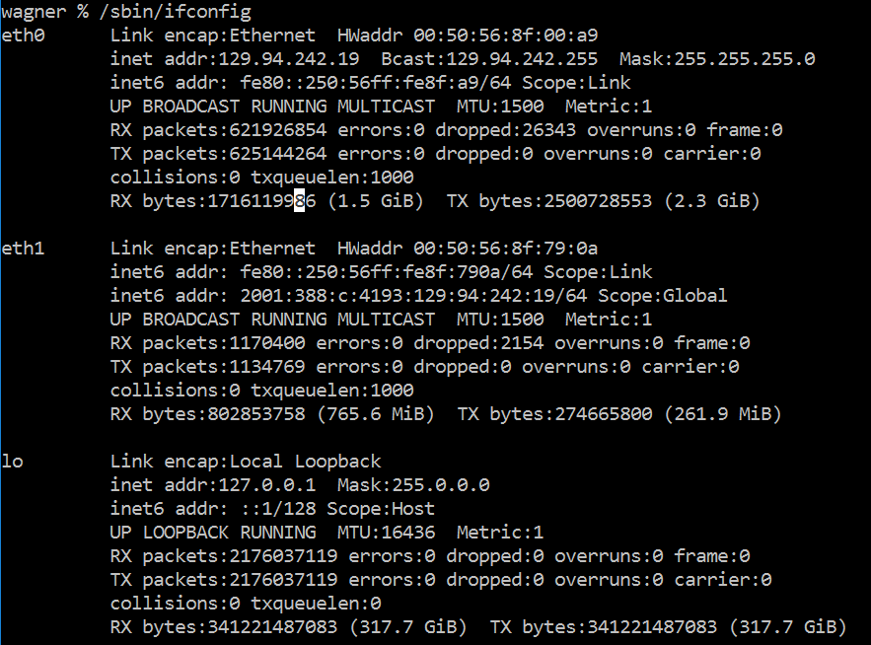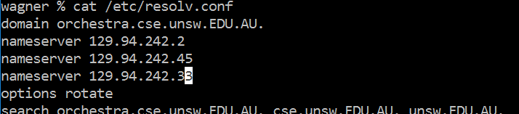

IP address: 129.94.242.19

Nameserver:129.94.242.2

## Q5.

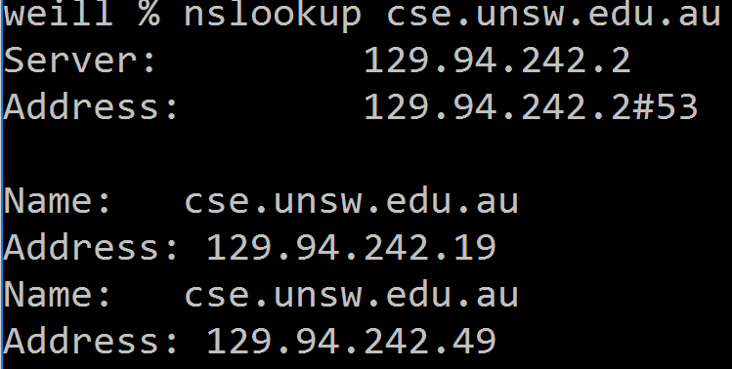

Nameserver: 129.94.252.2

IP:129.94.242.19/49

typeA

## Q6.

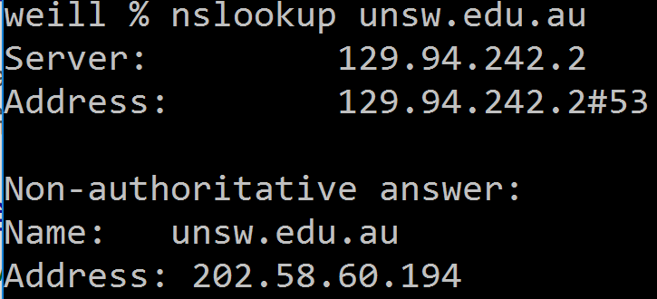

Nameserver is 129.94.242.2

IP address:202.58.60.194

Type A

## Q7.

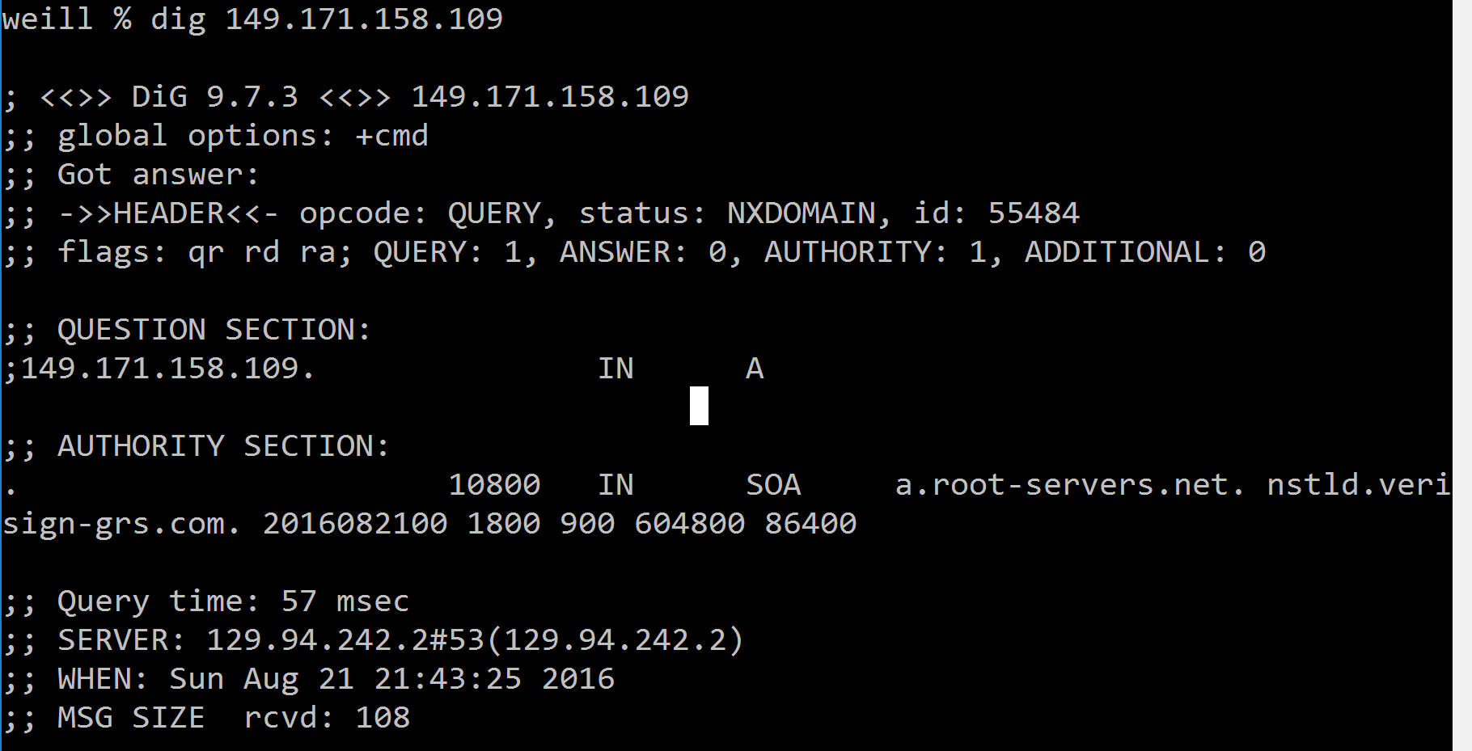

It’s 129.94.242.2

Type A

## Q8.

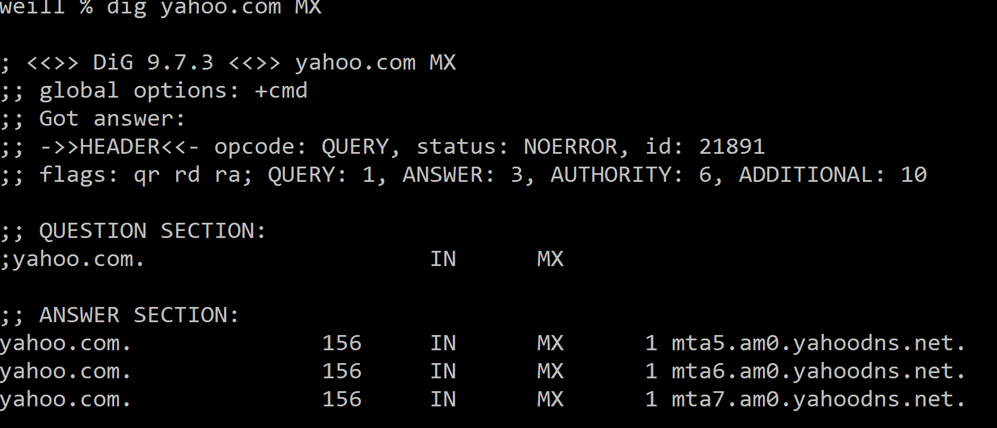

Yes, I got the AUTHORITY ANSWER.

First query the anthority servers which is respond for the yahoo.com, and this servers return the mx record for the query.

## Q9.

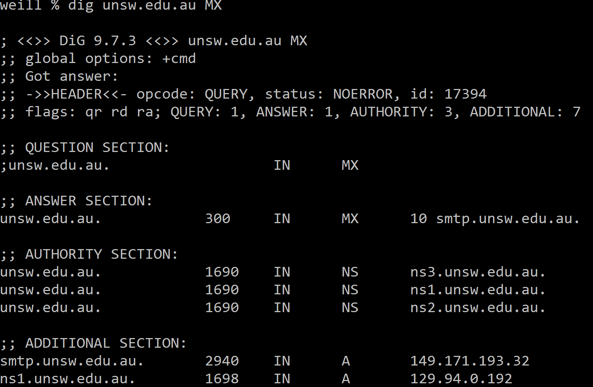

It’s smtp.unsw.edu.au

## Q10.

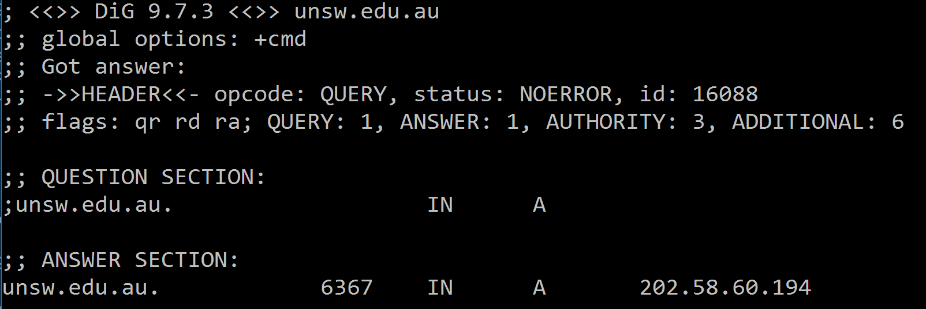 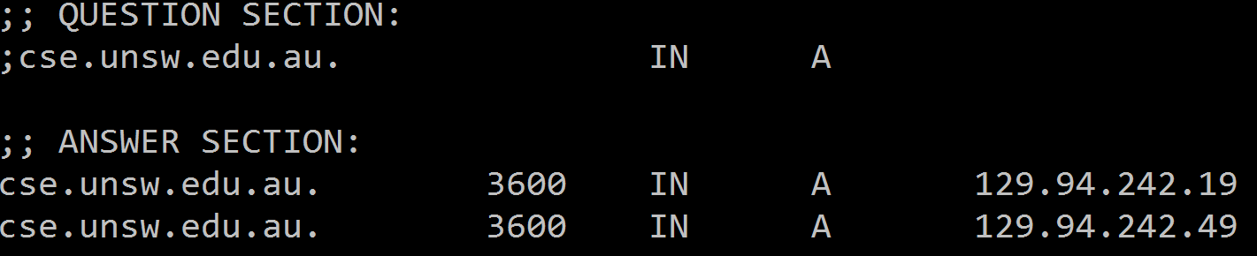

Through 4 servers

## Q12.

One machine could have several IP address or name.

For example several visual machine in the same physical machine.

## Q13.

NO

## Q14.

